SRS – Preschool Management App (Nursery, Jr KG, Sr KG)
Oct 21, 2026 · @Khilraj

1. Introduction
This document specifies a mobile app that lets pre-primary schools (Nursery, Junior KG, Senior KG) run daily operations and keep parents informed: staff and student onboarding, attendance, and photo or video updates of each child's activities.

1.1 Purpose
To give the design and development team one agreed description of what the product must do, who uses it, and how it is built on React Native and Firebase.

1.2 Scope
In scope for version 1:
- School self-registration with Super Admin approval
- Role-based access for Super Admin, Principal, Teacher and Parent
- Principal-managed teacher and student records
- Daily attendance by Teacher
- Activity capture (photo, video, note) by Teacher, visible to that child's parents
- Email and push notifications
Out of scope for version 1: fee collection, online payments, live bus tracking, in-app chat, and report cards. Section 9 and Section 10 list these as later phases.

1.3 Definitions
Term | Meaning
School (tenant) | One registered preschool. All its data is isolated from other schools.
Super Admin | Product owner's staff who approve or reject school registrations.
Principal | Head of one school; the first user created for that school after approval.
Teacher | Staff member created by the Principal; handles attendance and activities for assigned classes.
Student | The child. Children do not log in.
Parent | Guardian account linked to one or more students. The brief calls this the student login; it is the parent who signs in.
Activity post | A photo, video or note about a child, such as creative work or speech.

1.4 Technology baseline
React Native (Android and iOS), Firebase Authentication, Cloud Firestore, Cloud Storage, Cloud Functions, Firebase Cloud Messaging, and a transactional email service.

2. Overall description
Four roles share one app; what each sees after login depends on the role stored in their account. Every school's data is isolated from every other school.

2.1 User roles
Role | Created by | Main goals
Super Admin | Product owner (seeded manually) | Review school registrations, approve or reject with a message, suspend schools
Principal | System, on school approval | Add and manage teachers, students and classes; see school-wide attendance
Teacher | Principal | Mark attendance; capture or upload activity photos and videos for students in their class
Parent | Principal, when adding a student | See child's attendance, activity feed, pick-up and drop details, announcements

2.2 Operating environment
- Android 8+ and iOS 14+ phones through one React Native codebase
- Super Admin works from a web view or the same app; a simple web console is recommended because reviewing many registrations is easier on a large screen
- Firebase backend; no servers to manage
- Target region: India (Firebase project in an Indian region, for example asia-south1)

2.3 Assumptions
- Each school has one Principal account in version 1.
- A teacher belongs to one school and may be assigned to one or more classes.
- A student belongs to one class (Nursery, Junior KG or Senior KG, with optional sections such as A or B).
- A parent email can be linked to more than one child, for example siblings in the same school.
- Users have mobile internet; the app tolerates weak connections for attendance entry (see Section 8).

2.4 Constraints
- Children's photos, videos, Aadhaar numbers and birth certificates are sensitive; Section 8 sets the handling rules.
- Video upload size is capped to keep Firebase Storage costs predictable (Section 8).

3. End-to-end user flows
Registration is the only open door; after approval every login is created by someone above it: the Super Admin creates the Principal, and the Principal creates teachers and parents.
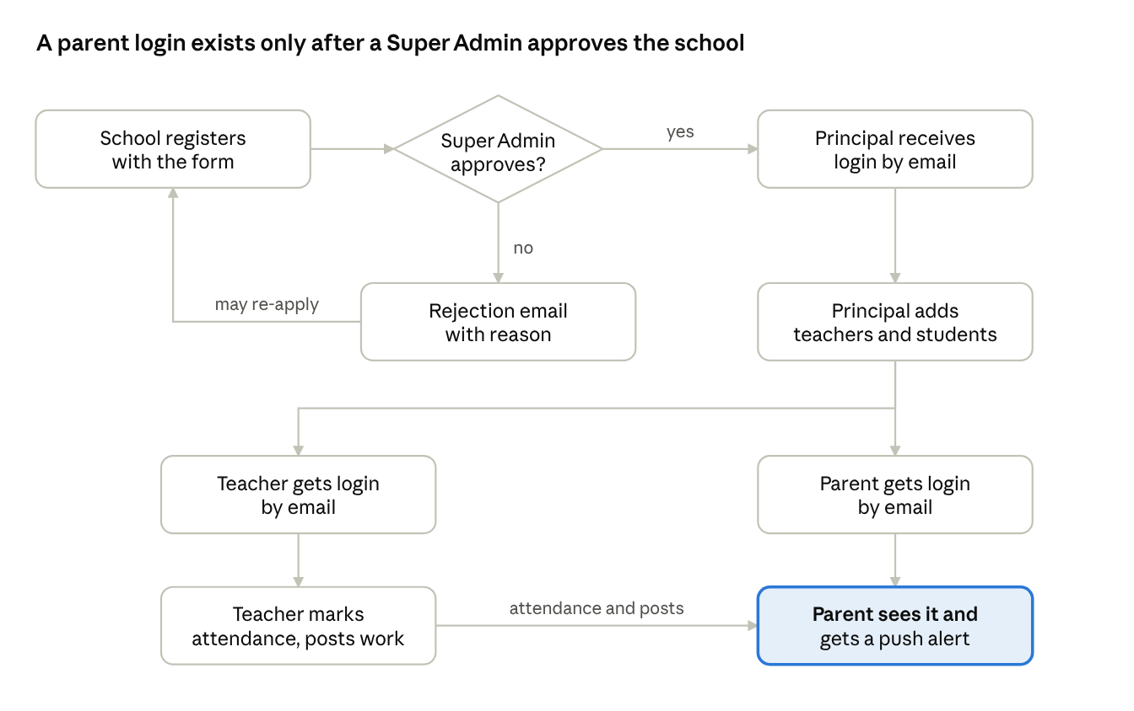
end-to-end flow · 1 decision, 3 roles
A rejected school can correct its details and apply again. Teachers and parents never register themselves.

3.1 Emails the system sends
Email | Sent to | Contains
Registration received | School's registered email | Confirmation that the application is under review
New registration | Super Admin | School details and a link to the review screen
Approval | School's registered email | Welcome message, login email, temporary password, app download link
Rejection | School's registered email | Reason typed by the Super Admin and how to re-apply
Teacher credentials | Teacher's email | School name, login email, temporary password
Parent credentials | Parent's email given in the student form | Child's name, school name, login email, temporary password

4. Functional requirements
Version 1 has 60 requirements in eight modules. Priority: M = must have, S = should have, C = could have (added by me beyond your brief).

4.1 Authentication and password recovery (AUTH)
ID | Requirement | Pri
AUTH-1 | Users sign in with email and password; the app opens the dashboard for the role stored on their account. | M
AUTH-2 | Forgot password: user enters their email and receives a reset link; the reply is the same whether or not the email exists. | M
AUTH-3 | Accounts created by the system start with a temporary password; the app forces a new password at first login. | M
AUTH-4 | Accounts of rejected, suspended or deactivated schools and users cannot sign in and see a clear message. | M
AUTH-5 | Sign-in is rate limited after repeated failures; sessions stay active until logout on the same phone. | S
AUTH-6 | Change password from the profile screen. | M

4.2 School registration (REG)
ID | Requirement | Pri
REG-1 | The first screen offers Login and Register School. | M
REG-2 | Registration form: school name, contact number, email ID, address (line, city, state, pincode), principal name. | M
REG-3 | Optional fields: school logo, board or UDISE number, website, number of students expected. | C
REG-4 | Validate formats (10-digit Indian mobile, email, 6-digit pincode) and reject an email already registered. | M
REG-5 | On submit the school is saved as Pending; the applicant sees a confirmation and receives an acknowledgement email. | M
REG-6 | An email with the school's details and a review link goes to the Super Admin on every new registration. | M
REG-7 | A rejected school may correct its details and re-apply. | S

4.3 Super Admin approval (SA)
ID | Requirement | Pri
SA-1 | List of registrations filtered by Pending, Approved, Rejected, with search by school name or city. | M
SA-2 | Detail view of one registration with all submitted data. | M
SA-3 | Approve: the system creates the Principal account on the school's registered email, generates a temporary password and emails login credentials with a welcome message. | M
SA-4 | Reject: Super Admin must enter a reason; a rejection email carrying that reason goes to the registered email. | M
SA-5 | Message templates for approval and rejection that the Super Admin can edit before sending. | S
SA-6 | Every decision is logged with who, when and the message sent. | M
SA-7 | Suspend or reactivate an approved school; resend credentials. | S

4.4 Principal dashboard (PR)
ID | Requirement | Pri
PR-1 | Dashboard shows today's attendance for the whole school, counts of teachers and students, and shortcuts to Add Teacher and Add Student. | M
PR-2 | Add Teacher form: name, contact number, Aadhaar number, address, email ID. | M
PR-3 | Extra teacher fields: photo, qualification, joining date, assigned class and section, emergency contact. | S
PR-4 | On saving a teacher, the system creates a login on that same email and emails credentials. | M
PR-5 | Add Student form: name, address, email ID (parent login), Aadhaar or birth certificate, father's contact number, mother's contact number, pick-up and drop type (Van or Personal). | M
PR-6 | Extra student fields: date of birth, class and section, photo, blood group, allergies, emergency contact. | S
PR-7 | If pick-up is Van, capture van number and driver contact; if Personal, capture names of authorised pick-up persons. | S
PR-8 | Birth certificate or Aadhaar is uploaded as an image or PDF and stored privately. | M
PR-9 | On saving a student, the system creates the parent login on the given email and emails credentials. An email already used by a parent links the new child to that account. | M
PR-10 | Lists of teachers and students with search; edit, deactivate and reassign class. | M
PR-11 | Principal can view attendance reports by class and date range, and every activity post of the school. | S

4.5 Attendance (ATT)
ID | Requirement | Pri
ATT-1 | Teacher opens a class and date (default today) and sees its students with everyone preset to Present. | M
ATT-2 | One tap toggles a student to Absent; optional Late status and a short reason. | M
ATT-3 | Saving writes one record per student per day; editing the same day is allowed, earlier days only for the Principal. | M
ATT-4 | Future dates cannot be marked. | M
ATT-5 | Parents receive a push notification when the child is marked absent, and the status shows on their home screen. | M
ATT-6 | Parent sees a monthly calendar of present, absent and late days with a percentage. | S
ATT-7 | Principal and Teacher can export a monthly class attendance sheet as PDF or CSV. | C

4.6 Activity capture (ACT)
ID | Requirement | Pri
ACT-1 | Teacher picks one or more students, then captures a photo or video with the camera or uploads from the gallery. | M
ACT-2 | Each post has a category (Creative work, Speech, Play, Learning, Other), an optional caption and date. | M
ACT-3 | Photos are compressed on the phone before upload; videos are limited to 60 seconds and 50 MB. | M
ACT-4 | Upload shows progress and resumes or retries after a dropped connection. | M
ACT-5 | A post tagged to several students appears in each parent's feed, but never to parents of untagged students. | M
ACT-6 | Teacher can edit a caption or delete their own post; Principal can delete any post. | M
ACT-7 | Parent receives a push notification for each new post about their child. | M
ACT-8 | Photo consent flag on the student record; students without consent cannot be tagged. | S

4.7 Parent portal (PAR)
ID | Requirement | Pri
PAR-1 | Home screen: child's name and class, today's attendance status, latest activity posts. | M
PAR-2 | Activity feed for the child, newest first, filter by category and date. | M
PAR-3 | Switch between children when the parent has more than one. | S
PAR-4 | View pick-up and drop details and teacher contact. | S
PAR-5 | Save a photo to the phone from the feed. | C
PAR-6 | Parents cannot edit student records; they request changes through the Principal. | M

4.8 Notifications and email (NOT)
ID | Requirement | Pri
NOT-1 | Emails: registration received, new registration to Super Admin, approval, rejection, teacher credentials, parent credentials, password reset. | M
NOT-2 | Push notifications: absence marked, new activity post, school announcement. | M
NOT-3 | In-app notification list per user with read and unread state. | S
NOT-4 | Announcements: Principal sends a notice to all parents or one class. | C

5. Role-permission matrix
These rules are enforced twice: by the screens a role can reach, and by Firestore and Storage security rules, so a changed app cannot bypass them. Scope means the user's own school only, and for Parent only their own children.
Capability | Super Admin | Principal | Teacher | Parent
Review, approve, reject schools | Yes | No | No | No
Suspend or reactivate a school | Yes | No | No | No
Add, edit, deactivate teachers | No | Yes | No | No
Add, edit, deactivate students and parent logins | No | Yes | No | No
View student identity documents (Aadhaar, birth certificate) | No | Yes | No | No
View student list | No | All in school | Own classes | Own children
Mark attendance | No | Correct past days | Own classes, today | No
View attendance | No | All in school | Own classes | Own children
Post activity photo or video | No | No | Own classes | No
View activity posts | No | All in school | Own classes | Own children only
Delete a post | No | Any in school | Own posts | No
Send announcements | No | Yes | No | No
The Super Admin never sees student data. Platform-level counts (schools, teachers, students) are enough for that role.

7. Screens and navigation
The app opens on a public landing screen, then routes to a role-specific tab layout after login.
Role | Screens
Public (before login) | Welcome, Login, Forgot Password, Register School, Registration Submitted, Pending Approval notice
Super Admin | Registrations list, Registration detail with Approve and Reject (message editor), Schools list, Audit log
Principal | Dashboard, Add Teacher, Teacher list and detail, Add Student, Student list and detail, Attendance reports, Activity gallery, Announcements, Profile
Teacher | Home (my classes), Mark Attendance, New Activity (camera, gallery, tag students, category, caption), My Posts, Student list, Profile
Parent | Home (child summary), Activity Feed, Attendance Calendar, Pick-up and Drop info, Notifications, Profile
Common to all roles: change password, notification settings, logout.
Design notes for a preschool audience: large touch targets, plain language, photo-first layouts, and English plus Hindi and Gujarati labels as a later option.

8. Non-functional requirements
The largest risk in this product is mishandling children's photos and identity documents, so security and privacy come first.
ID | Area | Requirement
NFR-1 | Tenant isolation | Every record carries a school ID. Security rules reject any read or write outside the caller's school.
NFR-2 | Role enforcement | Role and school ID are stored as Firebase Auth custom claims, set only by Cloud Functions; users cannot change them.
NFR-3 | Account creation | Teacher and parent accounts are created by a Cloud Function using the Admin SDK, never from the app, so the Principal's own session is not replaced.
NFR-4 | Credentials | Passwords are never stored in Firestore. Temporary passwords are random, expire, and must be changed at first login.
NFR-5 | Sensitive documents | Aadhaar numbers and birth certificates sit in a restricted collection and private Storage path readable only by that school's Principal. Show Aadhaar masked (last 4 digits) on screens.
NFR-6 | Media access | Photos and videos are served through short-lived signed URLs, not public links.
NFR-7 | Privacy compliance | Follow India's Digital Personal Data Protection Act 2023: parental consent for processing a child's data, stated purpose, and a process to delete a child's data on request. A lawyer should review the consent wording.
NFR-8 | Performance | Feed loads the first 20 posts in under 3 seconds on 4G; images load as thumbnails first.
NFR-9 | Offline | Attendance can be marked offline and syncs when the connection returns; uploads queue and retry.
NFR-10 | Storage cost | Compress images to about 1 MB, cap videos at 50 MB, and expire or archive media after a school-defined retention period.
NFR-11 | Availability | Relies on Firebase service levels; Cloud Functions retry failed emails and log failures for the Super Admin.
NFR-12 | Usability | Teacher marks a class of 25 in under 1 minute; posting an activity takes no more than 4 taps from Home.
NFR-13 | Auditability | Approvals, account creation, deletions and document views are logged with user and time.
NFR-14 | Backups | Scheduled Firestore export to a separate bucket, daily.

9. Recommended changes to the original brief
I kept your flow intact and changed or added the items below where the brief had a gap or a risk.
# | Your brief | What this SRS does instead | Why
1 | Email the login email and password | Email the login ID with a temporary password that must be changed at first login. A set-password link is the safer later upgrade. | Plain passwords in email can be read by anyone with access to the inbox.
2 | Student login | The login belongs to the Parent, linked to the child | The child is under 6 and never signs in. Siblings can share one parent account.
3 | Aadhaar card for teachers and students | Aadhaar stored in a restricted area, masked on screen; birth certificate accepted as the student alternative | Aadhaar is sensitive personal data and should be collected only where needed.
4 | Teacher scans or uploads child's work | Plus category, multi-student tagging, caption, and a photo-consent flag | Group activities are common; parents must have agreed to photos.
5 | Attendance informs parents | Absence push notification plus a monthly calendar for parents | Gives parents a timely alert and a record.
6 | Principal adds teachers and students | Plus class and section assignment | Attendance and activity posts need to know which class a teacher and a child belong to.
7 | Super Admin approves by email | Also a Super Admin screen with a status list and decision log | Email alone gives no record and is easy to miss.
8 | Not mentioned | Pick-up authorisation (named persons, or van number and driver) | Preschool safety: only authorised people collect a child.
9 | Not mentioned | Announcements from Principal | Simple and high value for parents; marked could-have.

Ideas for later versions
- Daily report: meals, nap, toilet, mood
- Parent absence request and leave note
- One-time code at pick-up
- Fee reminders and payment
- Live van tracking
- Parent-teacher chat
- Milestone and progress reports per term

10. Roadmap, risks and open questions
A small team can ship version 1 in about 14 to 18 weeks. These durations are rough estimates to be confirmed with the developers.

10.1 Phases
Phase | Content | Estimate | Exit gate
0. Foundation | UI design, Firebase project, security rules skeleton, email service | 2 weeks | Clickable prototype approved
1. Onboarding | Registration, Super Admin approval, Principal login, credentials email | 3 to 4 weeks | A test school can be registered, approved and logged in
2. People | Add teacher, add student, parent accounts, class assignment | 3 weeks | Teacher and parent receive working logins
3. Daily use | Attendance, activity capture and feed, push notifications | 4 to 5 weeks | A pilot class runs a full school day
4. Hardening | Security rule tests, DPDP consent flow, performance, store release | 2 to 3 weeks | Pilot school signs off; app live on Play Store and App Store

10.2 Risks
Risk | Effect | Mitigation
Child photo or Aadhaar data leak | Legal and reputation damage | Section 8 controls; rule tests; limited staff access
Media storage cost grows fast | Monthly bill rises with every school | Compression, size caps, retention period
Emails land in spam | Schools never receive credentials | Authenticated sending domain; Super Admin can resend
Parents share one phone or change email | Wrong person sees child's data | Principal can change parent email; passwords reset by link

10.3 Open questions
- ☐ One Principal per school, or can a school have a vice-principal with the same rights?
- ☐ Is the Super Admin a single person or a team that needs separate logins?
- ☐ Does each teacher own one class, or can a teacher teach several?
- ☐ Should parents be able to download or share activity photos?
- ☐ How long should activity media be kept: one academic year, or longer?
- ☐ Is the app sold per school as a subscription, and who handles billing?
- ☐ Languages needed at launch besides English?

